
Department of BES-1
DATA STRUCTURES THROUGH PYTHON(24SC1204)
I/IV-B.Tech-(II Sem), Academic Year: 2024-2025

Session-32 ( Splay Tree )
Instructional Objective:
- To learn the concept of splay tree
- To perform different operations on splay tree
Learning Outcomes:
- Able to know about splay tree construction
- Able to perform splay tree operations
Introduction:
In data structures, splay trees are the self-balancing or self-adjusted binary search trees. In other words, we can say that the splay trees are the variants of the binary search trees. The prerequisite for the splay trees that we should know about the binary search trees.
Explanation:
A splay tree is a self-balancing tree, but AVL and Red-Black trees are also self-balancing trees then. What makes the splay tree unique two trees. It has one extra property that makes it unique is splaying.

A splay tree contains the same operations as a Binary search tree , i.e., Insertion, deletion and searching, but it also contains one more operation, i.e., splaying. So. all the operations in the splay tree are followed by splaying.

Here splaying means that the operation that we are performing on any element should become the root node after performing some rearrangements.

Rotations:
There are six types of rotations used for splaying:
- Zig rotation (Right rotation)
- Zag rotation (Left rotation)
- Zig zag (Zig followed by zag)
- Zag zig (Zag followed by zig)
- Zig zig (two right rotations)
- Zag zag (two left rotations)
Factors required for selecting a type of rotation
The following are the factors used for selecting a type of rotation:
- Does the node which we are trying to rotate have a grandparent?
- Is the node left or right child of the parent?
- Is the node left or right child of the grandparent?

Example: 1
Consider the following splay tree

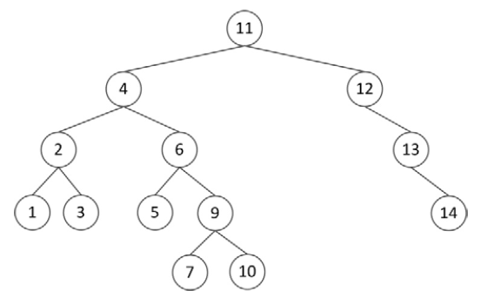

Perform a delete for the key 3 under the assumption that this is a bottom‐up splay tree.
Show each step. (6 points)

Answer:

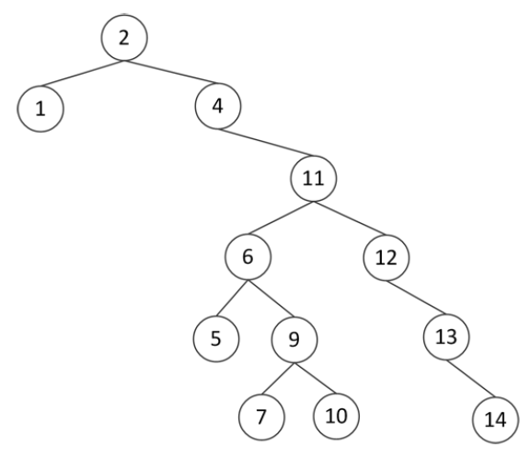
Review questions:
- What is a Splay Tree? Explain.
- What are the different types of rotations used for splaying in Splay Trees?
- Implement the different operations in Splay Trees.

Summary:
In this session, it was discussed about how different operations are performed in Splay Tree and the importance of the Splay Tree in Real World Projects.

